COMPUTER SCIENCE DEPARTMENT

Total Marks: 7.5
Obtained
Marks:

Introduction to Computer Science

Project Title:
Payroll Management System

Submitted To: Sir Ammad Noor.

Name: Kamil Abbas
Registration No: 2580350

Project Title : Payroll Management System.

1.Introduction:
The Payroll Management System is designed to automate the process of managing employee salaries, allowances, and deductions. It allows HR staff to calculate wages, track attendance, and generate pay slips efficiently. The system reduces errors, saves time, and ensures accurate salary management for organizations.
2.Problem Statement:
Currently, payroll operations are handled manually, leading to frequent calculation errors, delays in salary disbursement, and difficulties in maintaining records. This system will automate payroll processing, improving accuracy and efficiency.
3.Objectives:
- To develop a system for managing employee payroll records.
- To perform accurate salary calculations including allowances and deductions.
- To generate pay slips automatically.
- To maintain organized records of employee salaries and attendance.
4,Scope of Project:
Scope:
- Manage employee salary, attendance, and payroll records.
- Automate calculation of salaries and deductions.
- Generate pay slips for employees.
Limitation:
- Will not include tax filing or government compliance.
- Will not handle multi-branch payroll processing.

5,Tools & Technologies:
Use in this Project:
LAB/Tools | Language/Technology
1.ITC | 1.Excel.

We can also used:
LAB/Tools | Language/Technology
1.ITC | 1.HTML,CSS,Java Script

6.Methodology:
- Requirement Analysis:
- Purpose: Understand what the system needs to do.
- Activities:
- Talk to potential users (HR staff) to learn how payroll is currently done.
- Identify what information the system must handle, such as employee details, salary components, allowances, deductions, and pay slips.
- Outcome: A clear list of system requirements. This ensures the final system meets the needs of its users
i- Absent Deduction Formula
When an employee is absent without approved leave, a deduction is made from their basic salary proportional to the number of hours missed
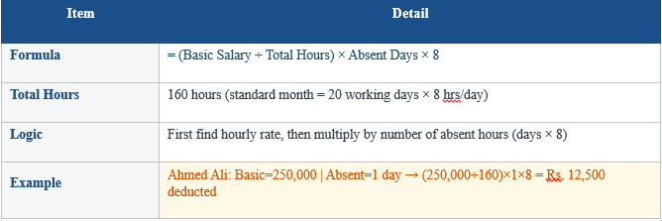
ii- Overtime Rate Formula (1.5x)And Overtime Pay Formula.
Overtime work is compensated at 1.5 times the normal hourly rate as per Pakistani labor law. The OT Rate formula first calculates the normal hourly rate, then multiplies by 1.5. Once the overtime rate is known, the total overtime pay is calculated by multiplying the OT rate by the actual number of overtime hours worked that month.
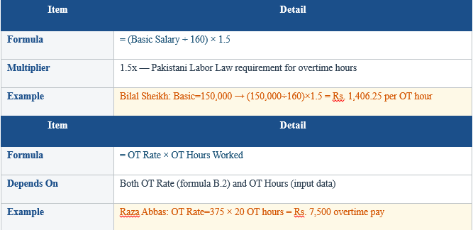
iii- Gross Salary Formula
The Gross Salary is the total income earned by an employee BEFORE any deductions (tax or EOBI). It combines the effective basic salary (after absent deduction), overtime pay, and allowances.
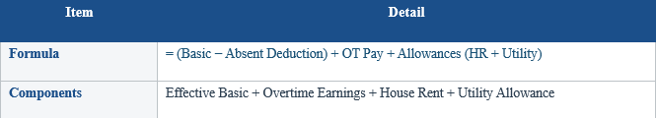
iv- EOBI Deduction
EOBI (Employees' Old-Age Benefits Institution) is a mandatory social security contribution governed by the EOBI Act 1976 of Pakistan. Every salaried employee must contribute a fixed amount each month.
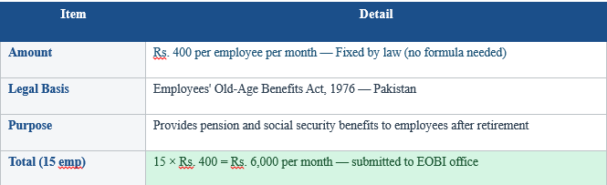
v- Net Pay Formula
Net Pay is the final amount that the employee actually receives in their bank account after all deductions (Income Tax + EOBI) have been subtracted from the Gross Salary
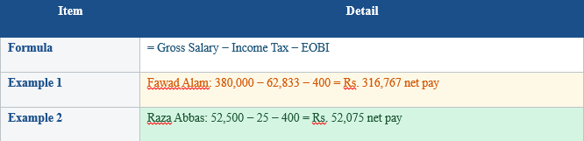
7- Detailed Payroll Register: 15 Employees
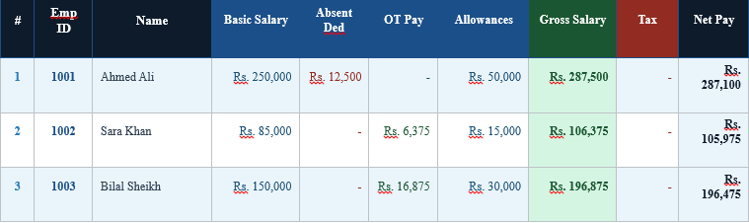
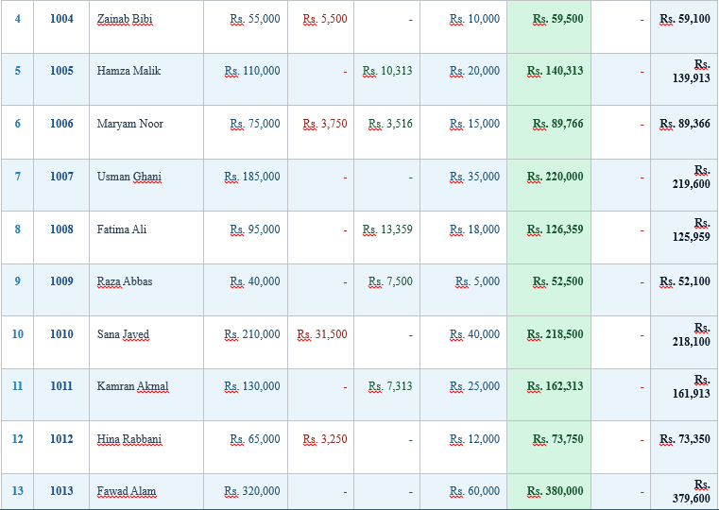
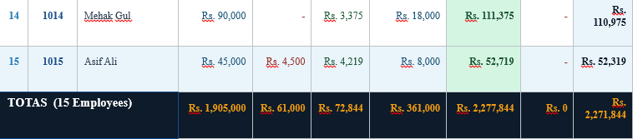


8-Design:
Flowchart Diagram:
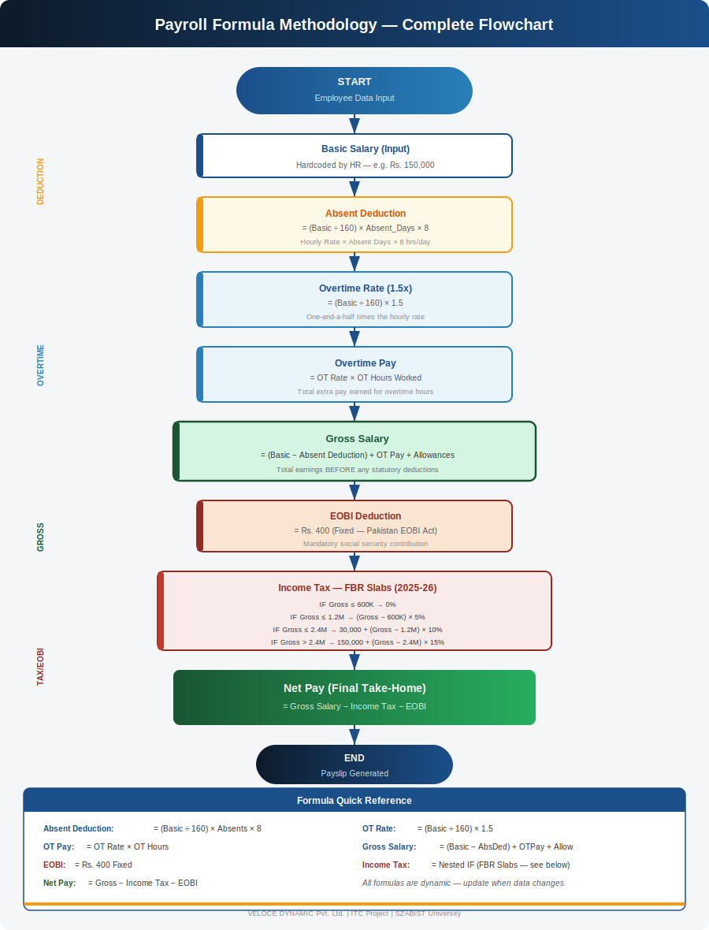
FBR Tax Slabs Table (2025-26)
Income Tax in Pakistan is levied and collected by the Federal Board of Revenue (FBR) under the Income Tax Ordinance 2001, amended annually through Finance Acts. The Finance Act 2025 introduced updated tax slabs effective for the fiscal year 2025-26 (July 2025 – June 2026).
This payroll system applies the FBR slab-based progressive tax system using a Nested IF formula in Excel. The tax is calculated on Annual Gross Salary and then divided by 12 for the monthly deduction.
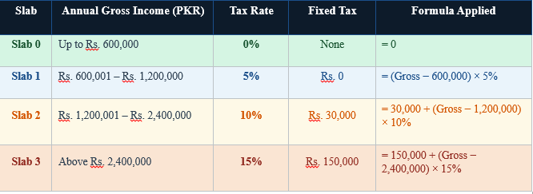
Worked Examples from VELOCE DYNAMIC Payroll
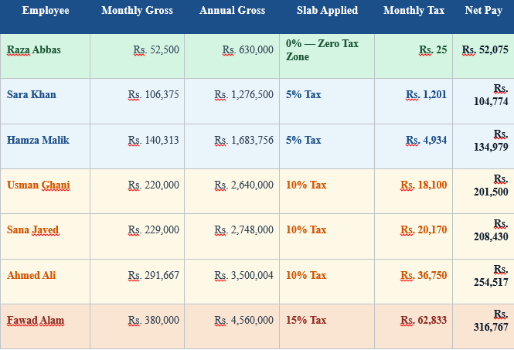
Implementation:
Purpose: Turn the design into a working system.
Activities:
- Write the code using chosen tools (Python, SQL, HTML/CSS/JS, or C++ depending on the project).
- Connect the database to the application.
- Implement features like salary calculation, attendance tracking, and pay slip generation
Outcome: A functional payroll system according to the design.

Testing:
Purpose: Ensure the system works correctly and efficiently.
Activities:
- Check if salary calculations are accurate.
- Test all features: adding employees, generating pay slips, storing records, etc.
- Fix any bugs or errors found.
- Verify the system is user-friendly.
Outcome: A reliable, error-free system ready for deployment.
8.Expected Outcome:
The Payroll Management System will automate salary calculations, generate accurate pay slips, and maintain employee records efficiently. It will minimize errors and reduce manual workload for HR staff.
8.Timeline:
Week | Task
1 | Requirement Analysis
2 | System Design (Flowchart)
3-4 | Implementation
5 | Testing & Debugging  Testing  &  Debugging
6 | Final Report & Submission

9.Conclusion:
The Payroll Management System automates employee salary processing, including allowances and deductions. It ensures accurate calculations, reduces errors, and improves efficiency in managing payroll records.

